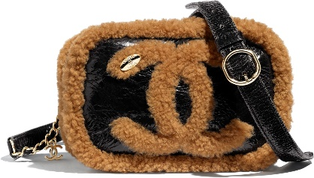 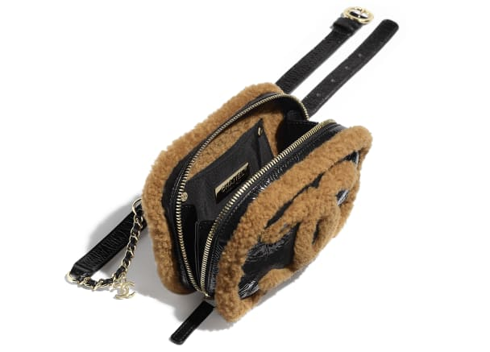

**Waist Bag**

Shiny Crumpled Sheepskin, Shearling Sheepskin & Gold-Tone Metal

Black & Brown

**CAN$4,625**

11 × 17 × 5 cmin

Reference: AS0406 B01575 N5275